Either die a hero or live long enough to see yourself becoming a villain. Some died a hero but their names lived long enough to be given the title of villain. One such name is Thomas Alva Edison.

With time and technology, the books are now one of many sources to impart knowledge. Internet being the biggest source of knowledge as of now is an education industry itself. The advantage of internet over traditional books are, it can’t be controlled enough by the authorities and you may stumble across some information that may change your entire perspective and this source may be hidden from public by authorities since ages. You stop or control the contents of the books but stopping the internet is not possible. Soft copies can be indestructible unless you cut the cables and electricity lines.

Well moving with Elon’s pace, we will not have to worry about power sheds in the near future but this will be our topic of discussion in the future. As of now we will look back in the history and discuss the pioneer of engineering Thomas Edison.

Edison one of the brightest minds of 1800s is widely known for his work of luminescence, but he was not the actual inventor of the light bulbs. I can’t comment if he was an inventor of not, but I can say he was a genius modifier and a businessman. In the west he gained fame by lighting up the bulbs when rest of the world was using torches and lamps. Lesser known fact is that original concept of bulbs was proposed by an Englishman **Frederick De Moleyns,** 40 years before Edison**.**

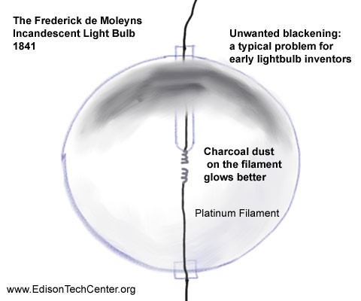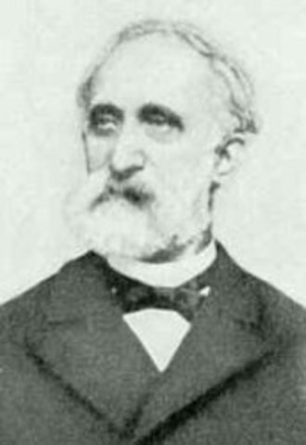 Fredrick De Moleyns Moleyns Bulb

He used platinum wires and carbon dust to produce his bulbs. Since Moleyns was way ahead of his time his ideas were not worked upon much and also his model was expensive to manufacture since platinum is costly and rthe blubs were mot commertially viable to manufacture. Another Englishman “**Joseph Swan**” demonstrated his light bulbs in year 1879, an year before Edisons demonstration. Still his model was not used commertially as it burnt out quickly. Now we know that the original concept of bulbs was not proposed by Edison, he modified it. Moleyns and Swan layed the stepping stones for Edison.

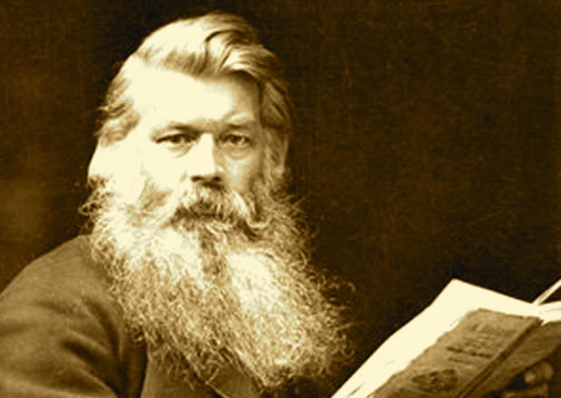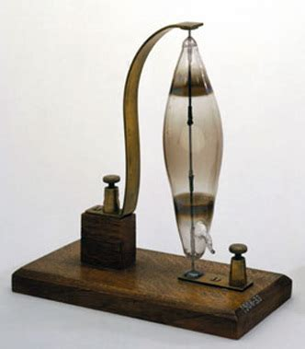 Joseph Swan Swan Bulb

Now a question arises, Since Swan and Edison demonstrated their model during the same period was there any argument between both the inventors?

There was a dispute between the two inventors regarding the patents and Swan sued Edison in court. Since Edison was hell of a businessman and businessmen are full of people skills, he managed to convince Swan to form a jont company to manufacture the light bulbs. History was not very kind on Swan and his name faded with time.

Still there is one argument that Edison should be called the father of bulbs since it was his 6000 failed attempts that led to creation of a successful model that we use till date. But here is a twis, Edison didn’t fixed the problems related to filamen, a black man in the late 1800s did it for him. This information was braught into light by the 2020 American Presidential election candidade **Joe Biden**. This statement made by him amazed me as those were the struggling period of the non whites and a black dude capable of applying science at such a high level must be very brave and have struggled a lot to become the top level man in white dominated nation.

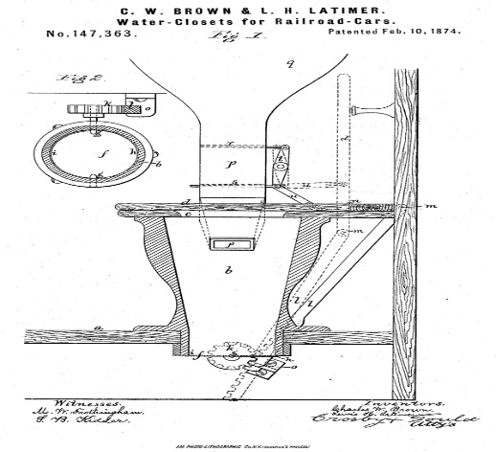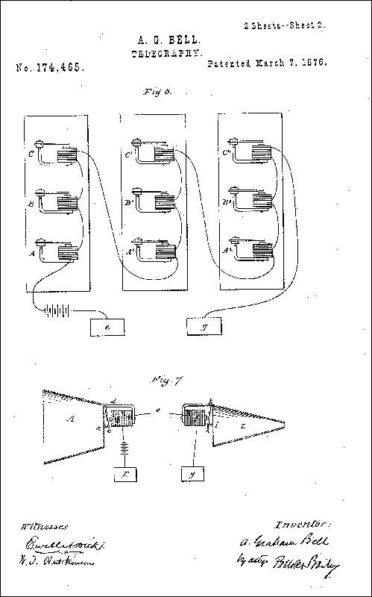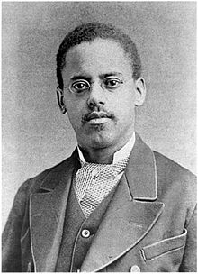**Lewis Howard Latimer** is the man referred by Biden in his speach. Belonging from a humble background he had financial insecurities but he still managed to educate himself and enter the line of engineering design, in his initial days he patiented a modified design for train compartment toiletary sustem, soon his brilliance was observen by **Alexzander Grahambell** and he hired him to develop drawings for his system. Bell with the help of Latimer was able to patient his devics hours before his rival. The credit for his widely accepted goes to Latimer.

Lewis Howard Latimer Grahambell radio system Water closet for railcars

Latimer’s potential and knowledge was soon observed by many other scientists of the era and Edison hired him to work. He played key role in Edison’s light bulb creation. The major problem with the filaments were fixed by him and his method of filamen production also got patient. Impressed by his brilliance Edison asked him to write his book on Light bulbs. Later he did few more patients one being a panel to reduce air temperature which can be referred as grandfather of Air conditioners.

We as a human have a tendancy to overlook every good deed a man have done in past and focus on one negative thing to pass a judgement. Realising this , just for a second rethink, Thomas Alva Edison a hero ?